Brad Morgan

Homework 6 – Econometric Analysis

**Part A**

Xi = α + βsmalli + ϒregaidi + ԑi

Regular class: E(Xi | small = 0, regaid = 0) = α 🡪 regular

Small class: E(Xi | small = 1) = α+β

Regular aid class: E(Xi | regaid = 1) = α+ϒ

α = average value of Xi

**Part B**

β = difference between a small class and regular class (small – regular)

ϒ = difference between a regular aid class and a regular class (regaid – regular)

**Part C**

* Below is the output for the regression that displays the correlation between the different characteristics of the Small and Regular Aid classes.
* The “_cons” coefficient is the Regular class value. The coefficients under Small and RegAid measure how far off the values are from the constant (Regular) mean
* The second chart displays the means across the class types. 2 is the mean value of the Regular class, which matches the constant in the first chart
* 1 = Small, 2 = Regular, 3 = Regular + Aid (RegAid)

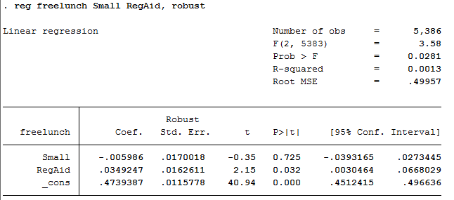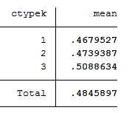

F-Test: 0.0281 🡪 we are 95% confident that we should reject the null hypothesis

R-squared: 0.0013 🡪 model has very little explanatory power

t-test: Small==0.725 🡪 not significant RegAid==0.032 🡪 significant

A 1 unit increase in a Small class causes a -0.00599 decrease in “freelunch”. A 1 unit increase in a Regular Aid class causes a 0.349 increase in “freelunch”.

Based on these two tables from “freelunch”, we see that 46.8% of students in a Small class will receive a free lunch. In the Regular Aid Class, 50.9% of students will receive a free lunch. The Small class has a negative coefficient which means that it has a negative correlation with “freelunch”. The RegAid class coefficient is positive which results in a positive correlation with “freelunch”.

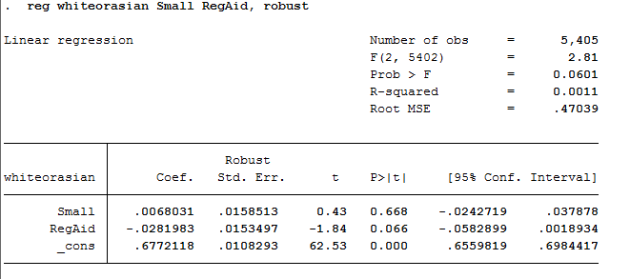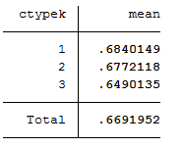

F-test: 0.0601 🡪 we are 90% confident that we should reject the null hypothesis

R-squared: 0.0011 🡪 model has very little explanatory power

t-test: Small == 0.668 🡪 not significant RegAid == 0.066 🡪 significant at 90% confidence

A 1 unit increase in a Small class causes a 0.0068 increase in “whiteorasian”. A 1 unit increase in a Regular Aid class causes a decrease in “whiteorasian” by 0.0282.

The chart above shows that 68.4% of students are either white or Asian in a small class and 64.9% in a regular aid class. The Small class coefficient is positive which results in a positive correlation in “whiteorasian” and a Regular Aid class is negative which results in a negative correlation with “whiteorasian”.

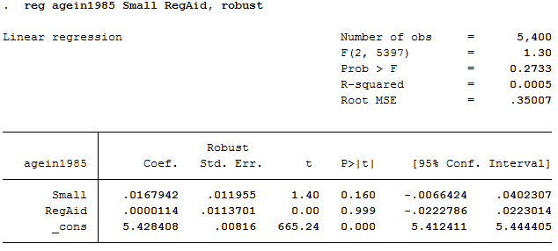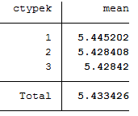

F-test: 0.2733 🡪 we should not reject the null hypothesis

R-squared: 0.0005 🡪 model has very little explanatory power, the least of the characteristics

t-test: Small == 0.160 🡪 not significant RegAid == 0.999 🡪 not significant

A 1 unit increase in a Small class causes a 0.0167 increase in “agein1985”. A 1 unit increase in a Regular Aid class causes a 0.000014 increase in “agein1985”.

The average age of a student in 1985 in a small class is 5.45 years old. In a regular aid class, the average age is 5.43 years old. The values are evenly distributed. We can also see that both coefficients are positive, which means that there is a positive correlation between the coefficients and “agein1985”.

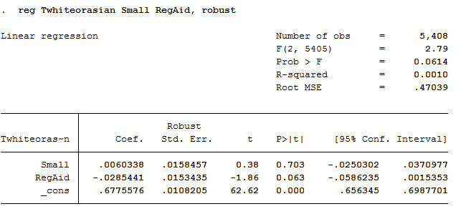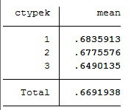

F-test: 0.0614 🡪 we are 90% confident that we should reject the null hypothesis

R-squared: 0.0010 🡪 model has little explanatory power

t-test: Small == 0.703 🡪 not significant RegAid == 0.063 🡪 significant at 90% confidence

A 1 unit increase in a Small class causes a 0.006 increase in “Twhiteorasian”. A 1 unit increase in a Regular Aid class causes a 0.0285 decrease in “Twhiteorasian”.

68.4% of teachers in a small class are white or Asian. 64.9% of teachers in a regular aid class are white or Asian. The Small class coefficients is positive which results in a positive correlation with “Twhiteorasian”. The RegAid coefficient, on the other hand, is negative which results in a negative correlation with “Twhiteorasian”.

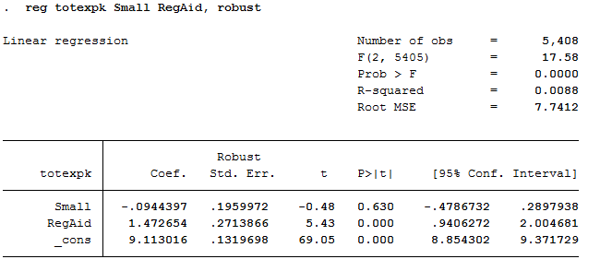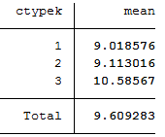

F-test: 0.0000 🡪 we are 99% confident that we should reject the null hypothesis

R-squared: 0.0088 🡪 this model has more explanatory power than the others in **Part C**

t-test: Small == 0.630 🡪 not significant RegAid == 0.000 🡪 significant at 99% confidence

A 1 unit increase in a Small class causes a 0.094 decrease in “totexpk”. A 1 unit increase in a Regular Aid class causes a 1.47 increase in “totexpk”.

For total years of experience, the average tenure is 9.02 years for a small class and 10.59 years for a regular aid class. This proves that the teachers in a regular aid class have more experience when instructing children with disabilities. The negative coefficient for a Small class results in a negative correlation with “totexpk” and the positive coefficient from RegAid results in a positive correlation with “totexpk”.

**Part D**

If the P-Value falls below 0.05, the value is significant. We will then reject the null hypothesis.

**Free Lunch (freelunch)**

P-Value(Small) == 0.725 🡪 NOT SIGNIFICANT

P-Value(RegAid) == 0.032 🡪 SIGNIFICANT at 95% confidence

P-Value(_cons) == 0.000 🡪 SIGNIFICANT

**White or Asian students (whiteorasian)**

P-Value(Small) == 0.668 🡪 NOT SIGNIFICANT

P-Value(RegAid) == 0.066 🡪 SIGNIFICANT at 90% confidence

P-Value(_cons) == 0.000 🡪 SIGNIFICANT

**Age in 1985 (agein1985)**

P-Value(Small) == 0.160 🡪 NOT SIGNIFICANT

P-Value(RegAid) == 0.999 🡪 NOT SIGNIFICANT

P-Value(_cons) ==0.000 🡪 SIGNIFICANT

**White or Asian Teachers (Twhiteorasian)**

P-Value(Small) == 0.703 🡪 NOT SIGNIFICANT

P-Value(RegAid) == 0.063 🡪 SIGNIFICANT at 90% confidence

P-Value(_cons) == 0.000 🡪 SIGNIFICANT

**Total Experience Teaching (totexpk)**

P-Value(Small) == 0.630 🡪 NOT SIGNIFICANT

P-Value(RegAid) == 0.000 🡪 SIGNIFICANT at 99% confidence

P-Value(_cons) == 0.000 🡪 SIGNIFICANT

**Part E**

To distinguish the significant values, we can use the “test” command to compare the significance of the small and regular aid classes. The “test” command runs an F-test and the F-test of the overall significance indicates whether your regression model provides a better fit to the data than a model that contains no independent variables. Also, the F-test appears on output chart. You can do either. I will post the output below.

**Free Lunch (freelunch)**

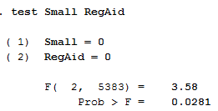

**White or Asian Students (whiteorasian)**

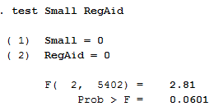

**Age in 1985 (agein1985)**

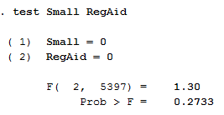

**White or Asian Teachers (Twhiteorasian)**

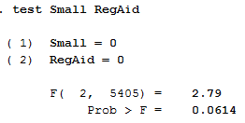

**Total Experience of Teachers (totexpk)**

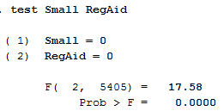

**Part F**

The regression for the following charts is based off of the variable “_Ischidk*” and the characteristics shown in **Part C**.

*For all of these tables below, I initially received all of the coefficients of the dummy variables. I screenshotted the dummy variables out to make the chart look neat. I included “_cons” but I had to take a separate screenshot for it.

**Free Lunch (freelunch)**

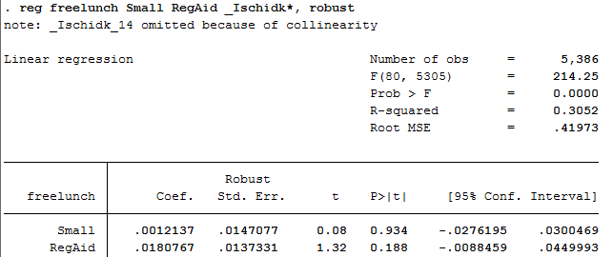



F-test: 0.0000 🡪 99% confident that we should reject the null hypothesis

R-squared: 0.3052 🡪 this model has explanatory power

t-test: Small == 0.934 🡪 not significant RegAid == 0.188 🡪 not significant

A 1 unit increase in a small class causes a 0.0012 increase in “freelunch”. A 1 unit increase in a regular aid class causes a 0.181 increase in “freelunch”.

R-squared says that 30.52% of the variation in “freelunch” is explained by small and regular aid classes. The other 69.48% is not explained (error). Both coefficients are positive which means that they are positively correlated with “freelunch”.

**White or Asian Students (whiteorasian)**

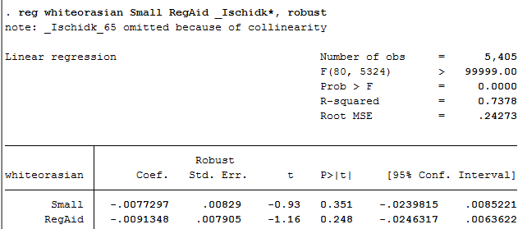



F-test: 0.0000 🡪 we are 99% confident that we should reject the null hypothesis

R-squared: 0.7378 🡪 model has a lot of explanatory power, good model

t-test: Small == 0.351 🡪 not significant RegAid == 0.248 🡪 not significant

A 1 unit increase in a small class causes a 0.0077 decrease in “whiteorasian”. A 1 unit increase in a regular aid class causes a 0.0091 decrease in “whiteorasian”.

R-squared states that 73.78% of the variation in “whiteorasian” is explained by small and regular aid classes. The other 26.22% is not explained (error). Both coefficients are negative which means that small and regular aid classes are negatively correlated with “whiteorasian”.

**Age in 1985 (agein1985)**

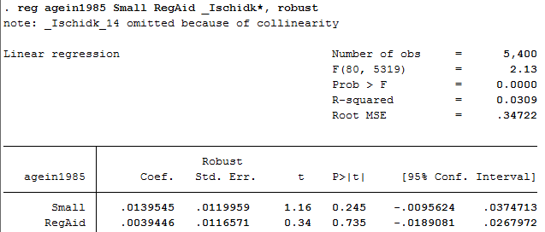



F-test: 0.0000 🡪 we are 99% confident that we should reject the null hypothesis

R-squared: 0.0309 🡪 little explanatory power

t-test: Small == 0.245 🡪 not significant RegAid == 0.735 🡪 not significant

A 1 unit increase in a small class causes a 0.014 increase in “agein1985”. A 1 unit increase in a regular aid class causes a 0.0039 increase in “agein1985”.

R-squared states that 3.09% of the variation in “agein1985” is explained by small and regular aid classes. The other 96.91% is not explained (error). Both coefficients are positive which means that small and regular aid classes are positively correlated with “agein1985”.

**White or Asian Teachers (Twhiteorasian)**

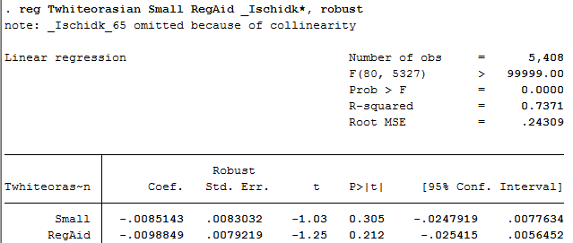



F-test: 0.0000 🡪 we are 99% confident that we should reject the null hypothesis

R-squared: 0.7371 🡪 model has a lot of explanatory power

t-test: Small == 0.305 🡪 not significant RegAid == 0.212 🡪 not significant

A 1 unit increase in a small class causes a 0.0085 decrease in “Twhiteorasian”. A 1 unit increase in a regular aid class causes a 0.0099 decrease in “Twhiteorasian”.

R-squared states that 73.71% of the variation in “Twhiteorasian” is explained by small and regular aid classes. The other 26.29% is not explained (error). Both coefficients are negative which means that both small and regular aid classes are negatively correlated with “Twhiteorasian”.

**Total Experience of Teachers (totexpk)**

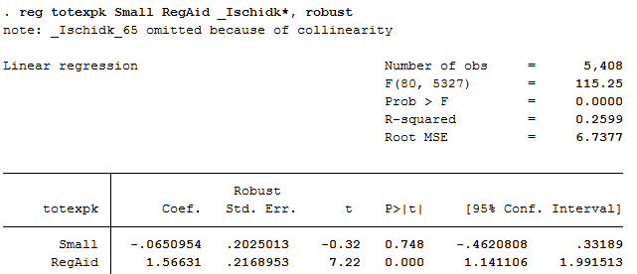



F-test: 0.0000 🡪 we are 99% confident that we should reject the null hypothesis

R-squared: 0.2599 🡪 model has explanatory power

t-test: Small == 0.748 🡪 not significant RegAid == 0.000 🡪 significant at 99%

R-squared states that 25.99% of the variation in “totexpk” is explained by small and regular aid classes. The other 74.01% is not explained (error). The small class coefficient is negative which means that it is negatively correlated with “totexpk” and the RegAid class coefficient is positive which means that there is a correlation between regular aid classes and “totexpk”.

**Part G**

Based off of the estimates, **Part F** DOES support the notion that the class types were randomly assigned conditional on the schools. There is a huge difference in the R-Squared values between Part C and Part F. Within any given school, the numbers are evenly distributed across the class types. However, across all of the schools, they are not evenly distributed.